**Data Mining (LAB – 4)**

**Question no 1**

**Part 1**

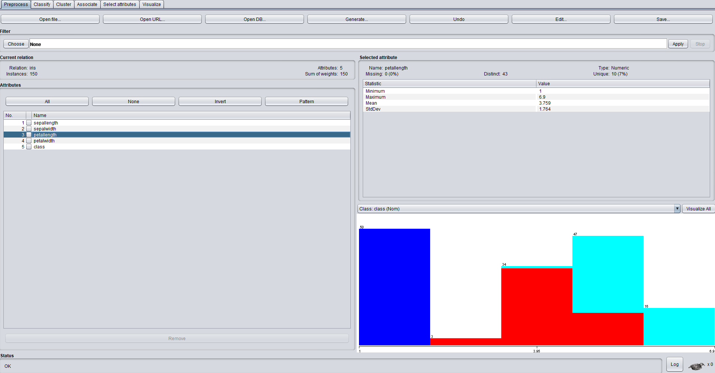

**Relation : iris total instances : 150**

**Attributes : 5 classes : 3**

**petalLength separates the data best**

**classify and Tree of a dataset**

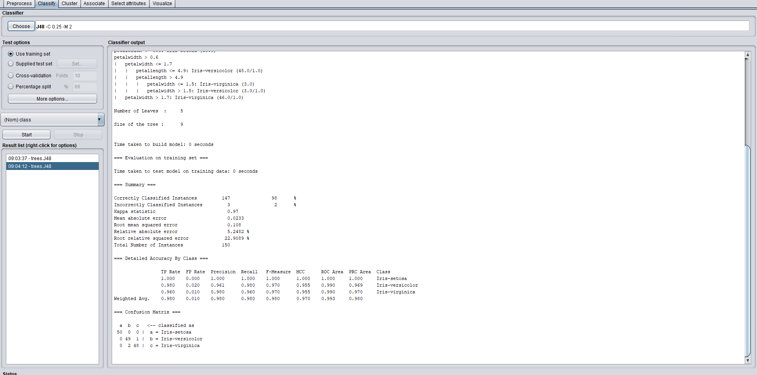

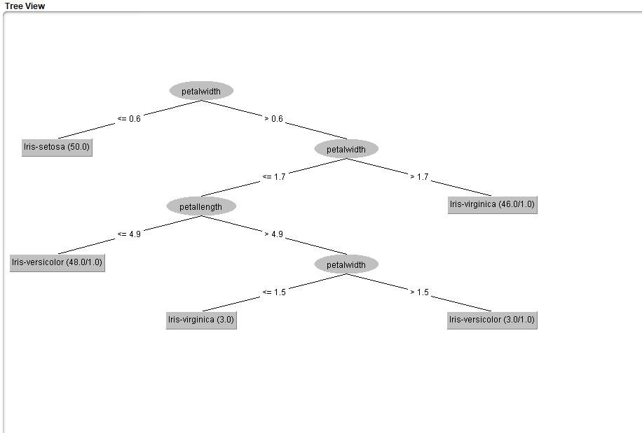

**QUESTION NO 2 : credit_g.arff dataset**

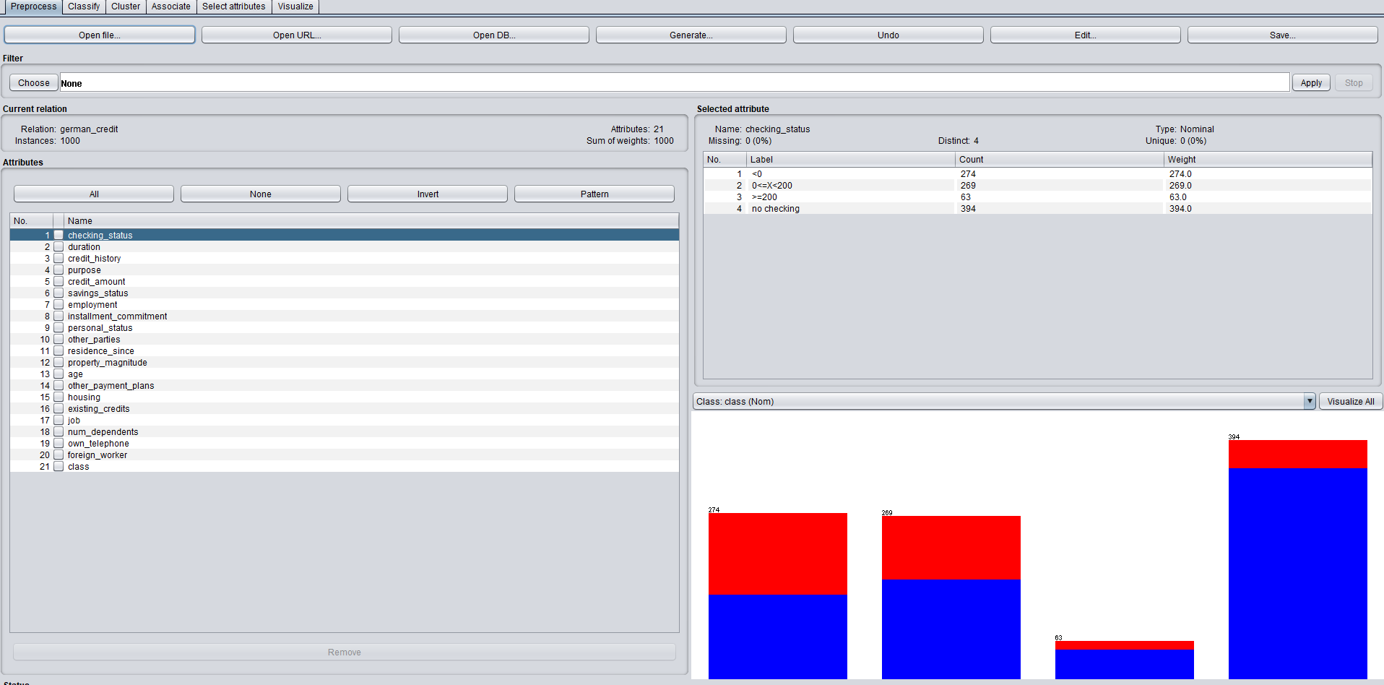

***J48***

**Correctly Classified Instances 247 72.6471 %**

**Incorrectly Classified Instances 93 27.3529 %**

***ZERO R***

**Correctly Classified Instances 250 73.5294 %**

**Incorrectly Classified Instances 90 26.4706 %**

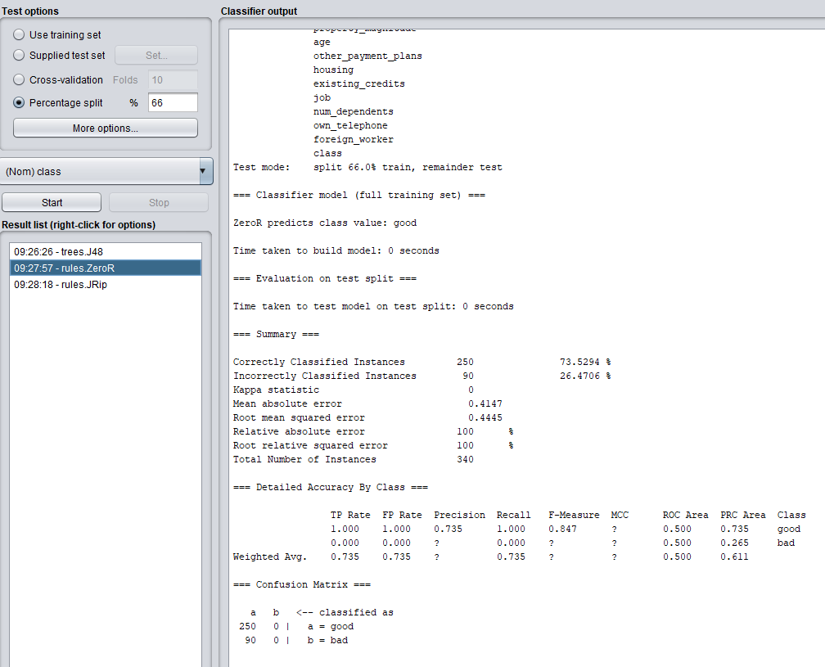

***JRip***

**Correctly Classified Instances 238 70 %**

**Incorrectly Classified Instances 102 30 %**

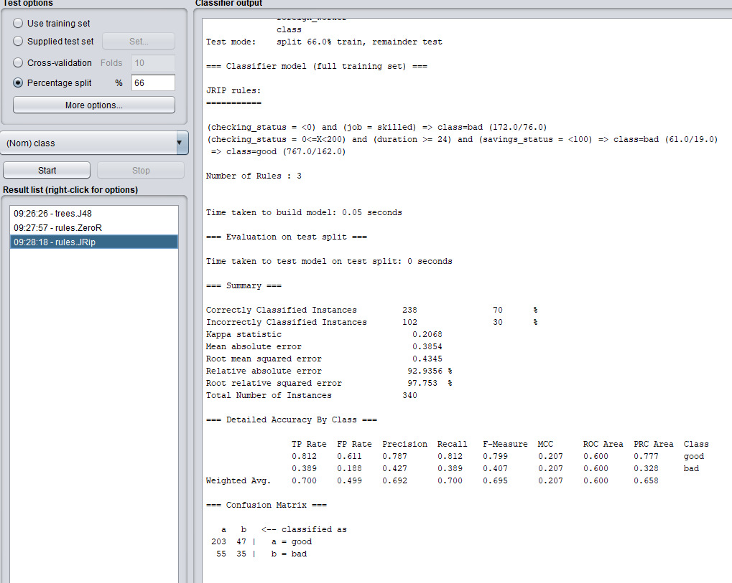

**Tree : J48**

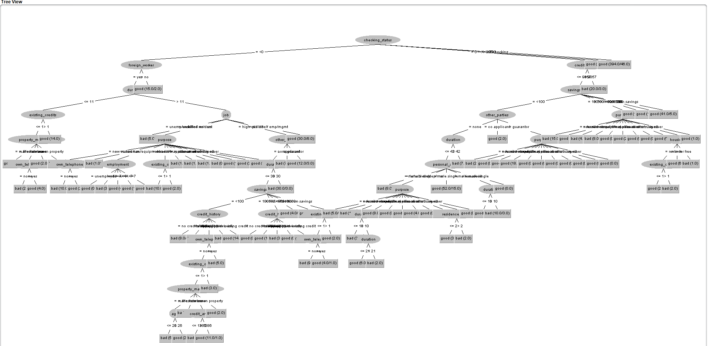

**Question no 3 : Naïve Bayes**